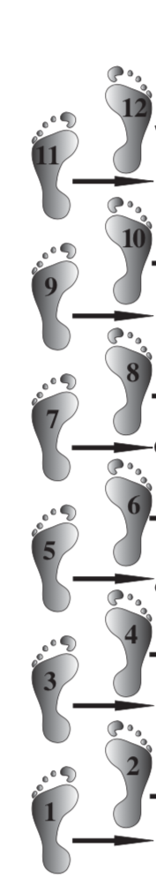

(Name of IG)

recognizes

**Twelfth-Step Within Day\***

with a

12th Step Within Workshop:

**Keeping our**

**Recovery Strong**

**Date**

**Times**

**Location**

**Address**

**address**

For information:

Contact name/telephone #

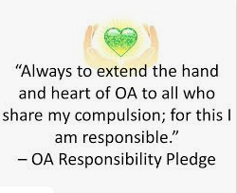

* 12th Step Within day is December 12th (12/12!), but we are celebrating on (date of workshop)